A Tour through Dolley Madison’s Washington City (in chronological order)

A) The Six Buildings: The Madisons moved to Washington in 1801, when James began his tenure as Jefferson’s Secretary of State. They stayed with the President for a month – and Jefferson seemed to prefer that they stay on – but they demurred. The couple found their own place in the Six Buildings on F Street, where they lived between 1801 and 1809. Dolley soon became renowned for her consummate skill as a hostess, frequently offering a livelier and more inviting assembly than what could be found at the President’s House. Nothing remains of the original structure. The approximate location is the current site of Shelly’s Back Room Tavern at 1331 F St., NW.

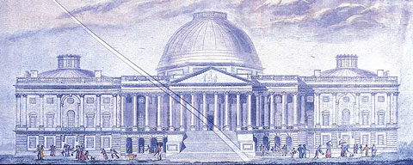
B) The Capitol Building: The site of President Madison’s inauguration in 1809. Many ladies, including Mrs. Madison, frequently sat in the galleries of the Supreme Court (which was located in the Senate wing) or the House, listening to the legal and political debates. But during the rancorous period surrounding the War of 1812, Dolley found the vitriolic speeches in the House more than she could bear. She wrote to a friend on January 14, 1813, “I stay quietly at home – as quietly as one can be, who has so much to feel at the expression, for & against their conduct.” Clearly, Congress had made their peace with the venerable Mrs. Madison by January 8, 1844, when they bestowed on her the singular honor of a seat on the House floor whenever she chose to visit. Tours of the Capitol can be arranged through one’s congressman or visit www.visitthecapitol.gov. (Image from the drawing of the Capitol Building’s architect, Charles Bulfinch, in 1826.)

C) Long’s Hotel: Immediately following the inauguration, the Madisons received formal visits at their home on F St. That evening, Long’s Hotel hosted the nation’s first Inaugural Ball. 400 guests were invited, but it was said that anyone could attend who could afford the ticket price. Contemporary accounts described the ball as “the most brilliant and crowded ever known in Washington.” Dolley’s friend, Margaret Bayard Smith, recalled that Dolley “looked a queen” in her buff-colored velvet gown and turban. Currently this is the site of the Library of Congress.

D) The President’s House: President Madison and the Lady Presidentress moved into the President’s House immediately after his inauguration in 1809. The “President’s Palace” was already informally known as the White House by then. Even before she had completed the transformative interior decorating blitz with her collaborator, Benjamin Latrobe, Dolley had launched the tradition of lavish entertaining in the White House. She arranged her crowded Wednesday night Drawing Rooms (called “squeezes”) with no less care the than the formal balls and state dinners they hosted. The couple would remain here until the British burned the edifice in 1814. Requests for tours must be made through one’s Congressman, and submitted at least three weeks in advance. See www.whitehouse.gov/history/tours. (Image from an 1816 watercolor by Benjamin Latrobe, showing a gutted White House.)

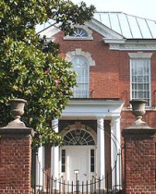
E) Belle Vue: Dolley Madison was whisked to the home of Charles Carroll on the afternoon of August 24, 1814, when the British marched into Washington. The core of the house is original, but was moved slightly from its original location when the Georgetown and Washington segments of Q street were united in 1915. It is currently called the Dumbarton House, owned by The Colonial Dames, and open for viewing: 2715 Q St., NW, Georgetown, (202) 337-2288.

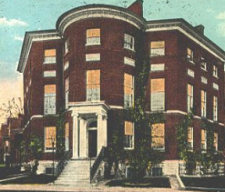
F) The Octagon House: Following the burning of the White House, and a month’s stay at their old residence on F Street (then the home of Anna and Richard Cutts), the Octagon House became the new home for the President and his wife. Dolley immediately resumed the tradition of the Wednesday Night Drawing Room, her social graces helping to soothe an irritable public weary of war. These parties were not mere frivolous entertainments; they had a serious purpose. There was a serious debate at this time about moving the capital to Philadelphia, and it was incumbent upon the Madisons to convince the skeptics that Washington City was resilient and deserved a second chance. The President’s office was on the second floor, and the Treaty of Ghent – ending the war of 1812 – was signed there on February 17, 1815. Later that year, the Madisons would move to the Seven Buildings at 1901 Pennsylvania Ave, at the corner of 19th St. (nothing remains of the Seven Buildings). They would remain here until they retired to Montpelier in 1817. The Octagon House is currently owned by the American Architectural Foundation, which offers limited visiting hours to the public: 1799 New York Ave, (202) 638-3221, nps.gov/history/nr/travel/wash/dc22.htm.

G) The Washington City Orphan Asylum: After the war of 1812, Dolley became the first First Lady to champion a charitable cause: an orphanage. She donated $20 and a cow, and helped to cut patterns for the girls’ clothes. The site is roughly between 900 and 906 H Street, but the building is no longer there.

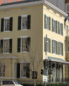
H) Home of the widowed Mrs. Madison: After her husband’s death, Dolley returned to Washington, living at the former home of Anna and Richard Cutts, her sister and brother-in-law. There she remained for most of the years between 1837 and her death in 1849. She immediately resumed the active social life which made her such a beloved fixture in Washington City. The first person to pay his respects to her was President John Quincy Adams. In May of 1848, the house caught fire, but Dolley refused to leave before her husband’s papers were secured. Though called “The Dolley Madison House” today, this bright yellow building is currently being used as office space for the U. S. Court of Appeals, 717 Madison Place. It is not open for public viewing, though there is a historical marker on the wall.

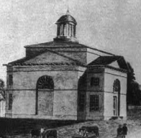
I) St. John’s Episcopal Church: Dolley Madison was confirmed here on July 15, 1845. The next day she wrote to her nephew: “And now my dear Richard I will tell you on what our thoughts have dwelt a great deal – it was to become worthy of membership in the Church which I have attended for the last forty years.” Her funeral would be held at this church exactly four years after that letter was written, and hundreds would come to pay their respects. The City of Washington closed down to provide a state funeral for her, the largest the capital had ever seen. President Taylor referred to her as the “First Lady” in his eulogy, the first time that term was used. The church is located at the corner of 16th and H Streets, facing Lafayette Square. (1816 Watercolor by Benjamin Latrobe, as it looked when it was built.)

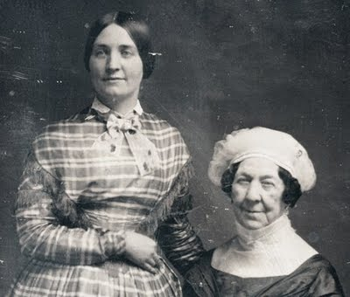
J) The Washington Monument: Dolley Madison, along with the widows of Alexander Hamilton and John Quincy Adams, united forces to raise funds for the Washington Monument. Mrs. Madison was of course invited to be present at the laying of the cornerstone on the Fourth of July, 1848. She sat at the dais with President Polk and numerous other distinguished guests, including a young Congressman named Abraham Lincoln. It was to be her last public appearance. (Above, an 1848 daguerreotype of Dolley Madison with her niece and constant companion, Anna Payne.)

